Ref Tender No:13/09/2025-26
Date:19/09/2025

The Secretary,
Ayaparambu Milk Co-Operative Society
Alappuzha-690517

Respected Sir,
GENFOCUS is a Electronic house operating in the Electronic industry for the past 08+ years. We have executed projects in the local as well as overseas market and has got a good clientele world-wide.

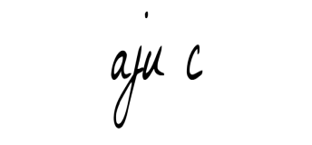
Aju.c
Authorised signatory.
Thanking You
. 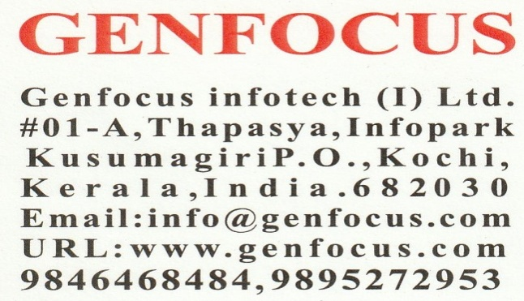

COST OF EWS ONLY

ITMES | MAKE | TOTAL | REMARKS
The cost of implementing “EWS ONLY | ESSAE | 19600.00 | NILL
TERMS AND CONDITIONS
Onsite Support
We have got a service technician in place for providing adequate support for the Office in time.
Payment Terms
100% against Confirmed order
Warranty
GENFOCUS warrants that the deliverables will meet specifications. The period of warranty
is limited to 12 months from the date of delivery or 12 months from the date of
installation, whichever is earlier. The guarantee however does not cover any damage
resulting from normal wear and tear or improper attendance or mishandling of the
equipment during repairs by personnel other than the supplier or his authorized
agents. Except for the warranties mentioned above, GENFOCUS excludes and disclaims
all conditions, warranties, statements, whether express, implied or statutory.
This warranty however does not cover glass, rubber components and load cell used
in the various equipments. This warranty also does not cover defects arising out of
willful damage/operator error/negligence, power line related defect, damages by
rats/rodents etc. Such repairs will be on a chargeable basis. The following cases will
not be covered under the warranty clause and repair/replacement of these will be on chargeable basis


